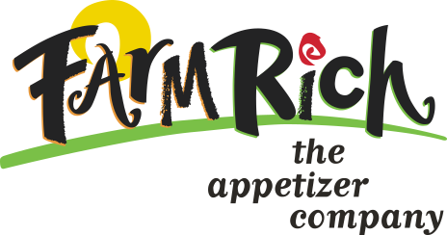
65282
Farm Rich® Pepperoni Pizzatas

Nutrition Facts Amount per School Serving
Serving Size 2 sticks = 2 oz meat/meat alternate and 1.75 serving bread alternate

Amount per Serving
Calories 360 Calories from Fat 170

% Daily Value*
Protein 19g Vitamin A 459IU 10%
Total Fat 19g 30% Vitamin C 1.63mg 2%
Saturated Fat 8g 42% Calcium 340mg 35%
Trans Fat 0g
Cholesterol 35mg 12% Iron 1.22mg 6%
Sodium 920mg 38%
Total Carbohydrate 28g 9%
Dietary Fiber <1g 4%
Sugars 3g

Weight per stick, average: 62 grams
Cheese content of product: 32.89%
Weight of cheese per stick, average: 22.36 grams
1.0 oz (28.34 grams) of cheese equals 1.00 meat alternate
22.36g x 2 sticks 44.72 grams
Pepperoni content of product: 11.36%
1.17 oz = 1 oz protein 6.05 grams
6.05g x 2 sticks 12.1 grams
Dough content of product: 41%
Enriched flour content of dough per stick, average: 13.62 grams
14.75 grams of enriched flour equals 1 slice bread credit.
13.62g x 2 sticks 27.24 grams

We certify that the above information is true and correct.

_____________________________
Raymond L. Jones
Vice President, Food Safety
& Shrimp Procurement July 3, 2003
P.O. Box 20670 St. Simons Island, GA 31522 1-800-654-9731

